**EERE 335 Automation**

**Step 1:** Place files into specific folder.

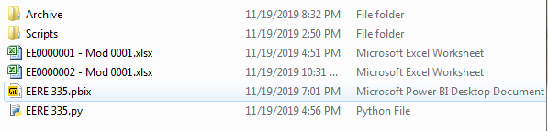

**Step 2:** Code runs, loading data into database, and moving files to Archive folder.

1. Picture of Empty Database

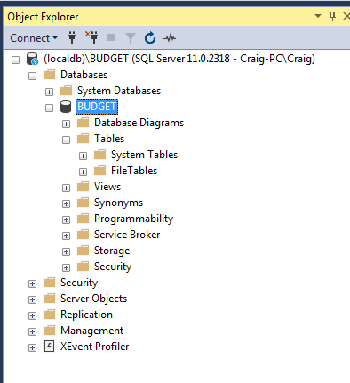

1. Picture of Python successfully running the files from Step 1.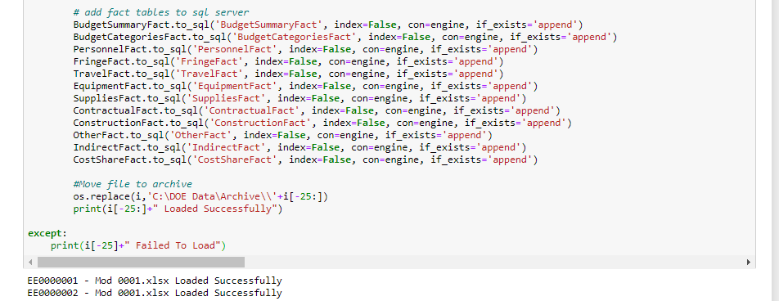
2. Tables loaded from files in Database.

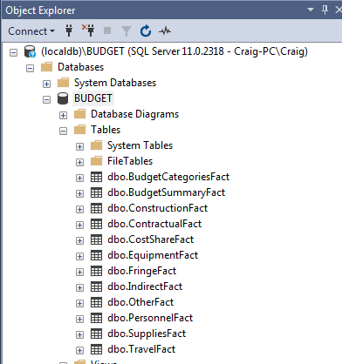

1. Files moved to Archive

